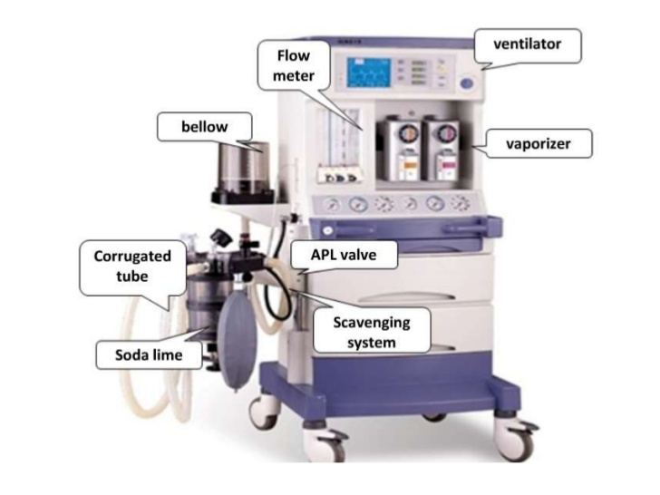

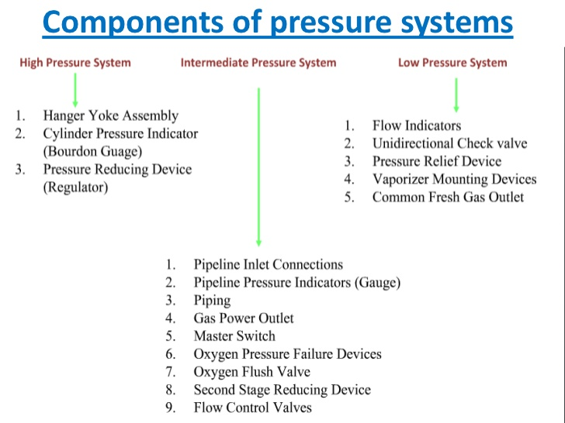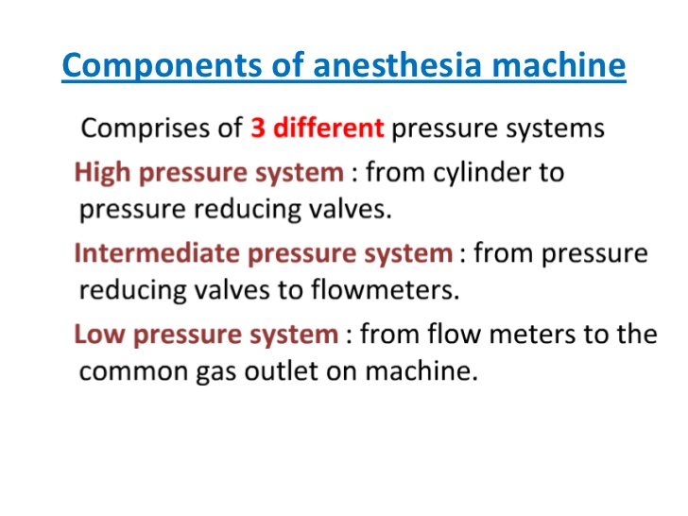

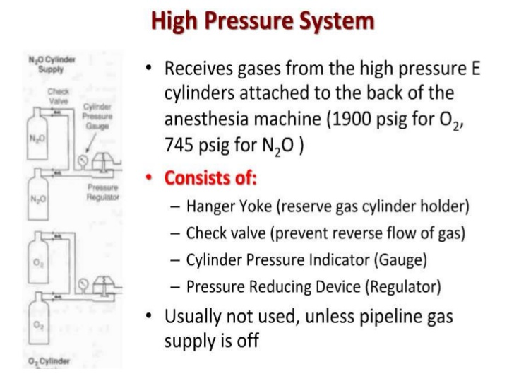

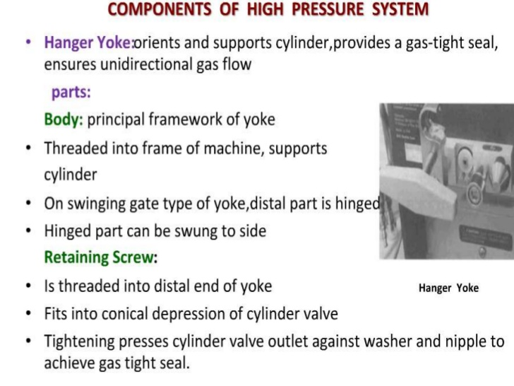

BODY
❖ It is threaded into the frame of the machine.
❖ It provides support for the cylinder(s).
❖ Commonly the swinging ga...

RETAINING SCREW
❖ It is threaded into the distal end of the yoke.
❖ Tightening the screw presses the outlet of the
cylinde...

Basic Schematics
 