Group Assignment for Summer 3 IT students

Question 1: Write an html code which displays the output shown below. [Form ]

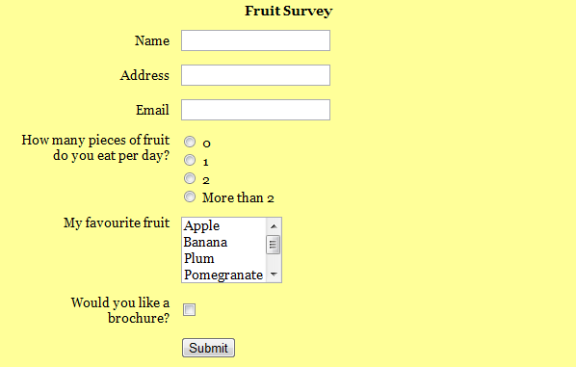

Question 2: Write an html code to display the output shown below [Table ]

Note:
- The number of members in a group should not exceed five (5).
- You have to submit only the hardcopy printouts of the codes.
- Submission of the assignment should be before the final exam of the course.

