Unit II - PowerPoint for Audio-video Support ELT lessons

Objectives

At the end of this unit, you will be able to:
- Produce contents into a slide
- Add different visuals into a slide
- Record/narrate slides

Introduction

Microsoft PowerPoint is the app used to give presentations. You're likely to see PowerPoint presentations used for everything from the world's largest companies to grade school teachers sharing lessons.

Like any tool, PowerPoint is incredibly useful when used properly for present. You can use it as an aid on your speaking engagements to build comfort and drive points visually with your audience.
- Has anyone of you used PowerPoint? If yes, for what purpose?

- What functions do you think PowerPoint can have? Share your ideas in threes.

Getting Ready

PowerPoint's Ribbon

- The Ribbon
The ribbon menu is found across many of Microsoft's apps, such as Word, Excel, and PowerPoint. It lives above the main area of the application.
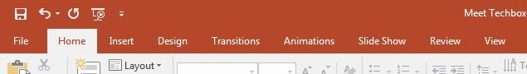
The PowerPoint ribbon lets you switch between various tabs. It contains a series of tabs that you can switch between. Each of these have a unique set of tools to work with your presentation differently. When you switch tabs on the ribbon, you'll see new buttons and options to modify your presentation:
- File - Save, share, and export your presentation.
- Home - A general purpose collection of the most common tools that you'll use in PowerPoint.
- Insert - An all-in-one tool to add every imagine-able type of content, such as tables, pictures, charts, video, and more.
- Design - Controls the overall look and feel of your presentation with theme and style settings.
- Transitions - Add animations when you switch slides.
- Animations - Controls the order and style that objects will enter or exit your slide with.

- Slide Show –
Control settings related to the way your presentation appears when sharing it with an audience.
- Home Tab
Use it for: a general selection of the most popular tools in PowerPoint.
I usually stay on the Home tab when I'm working in PowerPoint. The Home tab is the default and has many of the most commonly used tools, all in one bar from adding a new slide to changing text and paragraph settings.
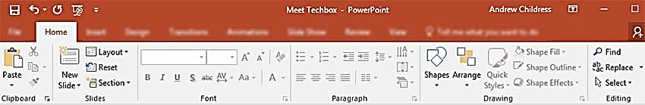
- Insert Tab
When you're working on adding content to a slide, the Insert tab has every possible tool to add new content to a slide. The Insert tab has the tools you need to add tables, pictures, charts, and more.
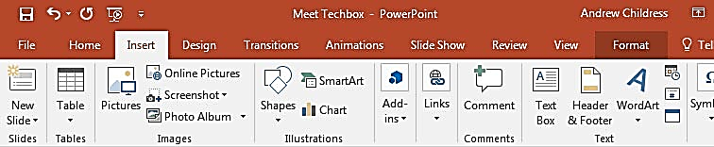

- Views
PowerPoint has a variety of views which are simply different ways to work with the same presentation. You can change the view in order to get a different perspective on your content.
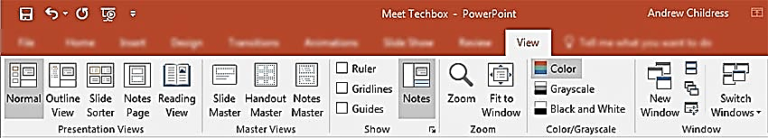
In the screenshot below, you can see the difference between the default Normal view and Slide Sorter view. Normal view shows each slide front and center, while Slide Sorter view creates thumbnails that you can drag and drop to reorder the presentation.

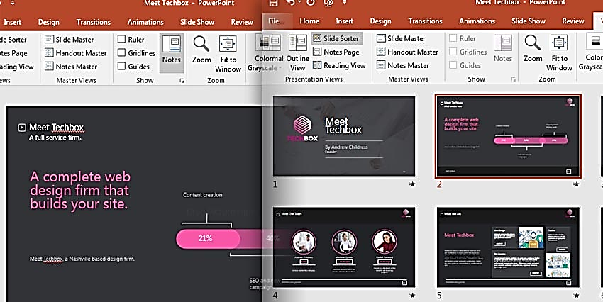

- Design Tab
An attractive presentation can really grab your audience's attention. We use themes and styles in PowerPoint to add visual appeal to the presentation, and the Design tab really controls these settings.
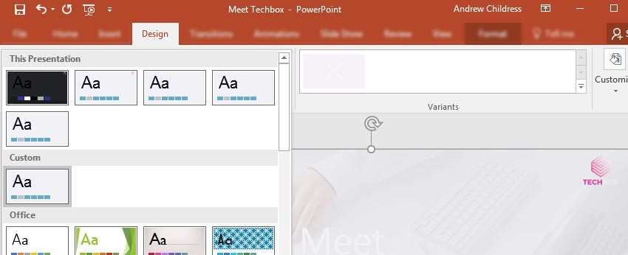

Quick Access Toolbar

Like the tabs and ribbon with other Microsoft Office products, you also have the Quick Access Toolbar. As the name implies, this feature allows you to perform quick actions.
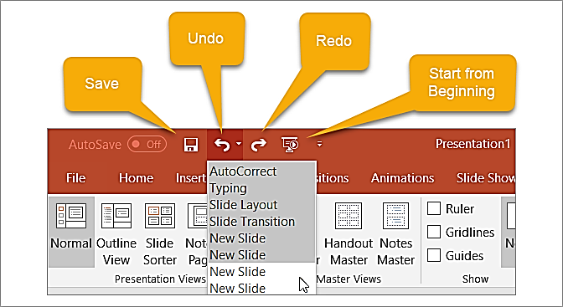
- The Save button lets you easily save the file you are working on with the current file name.
- If you make a mistake and want to undo it, just click the Undo button. If you click it once, it will undo the last action you took. If you keep clicking it, it will undo each previous action by moving backward. Alternatively, you can click the arrow next to the Undo button and highlight all actions you want to undo.
- If you undo an action with the button, the Redo button will then be clickable. This lets you redo what you have just undone. Like the Undo button, you can redo your last action with one click or use the arrow next to the Redo button to redo multiple actions.
- The Presentation button lets you start your slideshow as it will be viewed by others. It should take up your entire screen

for a nice view of the presentation at any time during your creating or editing processes.
You can select the arrow on the right of the Quick Access Toolbar to add or remove buttons from it easily. You can also see more commands available or move the toolbar below the ribbon.

Adding Slides

To insert a new slide, go to the Insert tab on PowerPoint's ribbon. Then, click on the New Slide button to add a new slide to your presentation.
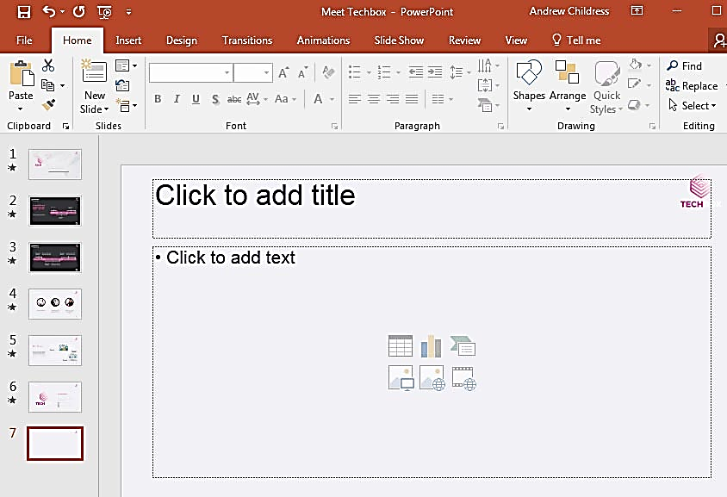
A new slide will have basic placeholders to add your content to in PowerPoint.

Adding Content

Content is what defines each and every slide. PowerPoint accommodates a wide range of content like text, graphs, tables, charts, and more. The easiest way to add content is to start off by choosing a Layout, which you can choose from the Home tab.
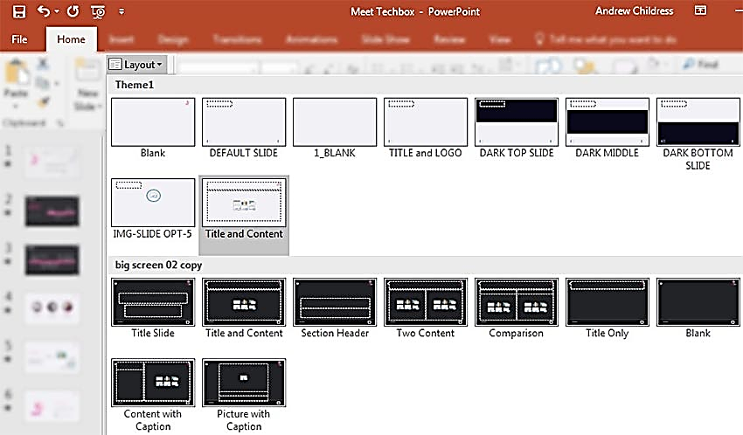
These layouts have content boxes that are easy to add your own content to. Simply choose a layout, and then start adding your content.

Choose Theme and Style

fter you build out your presentation's content, it's a great idea to think about adding visual style. For this, you'll jump over to the Design tab, and click on one of the thumbnails for a theme.
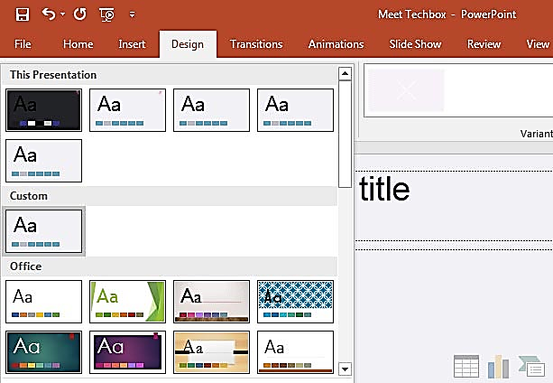
Using a PowerPoint theme is the preferred alternative to adding backgrounds, color and type styles to each and every slide. Changing the theme typically will adjust the entire presentation simultaneously. This greatly reduces the time involved with building a presentation.

Adding Audio & Video

The following steps will help you add audio or video file to the slides which can be played during the presentation.

Step 1 − Go to the Media group under the Insert ribbon
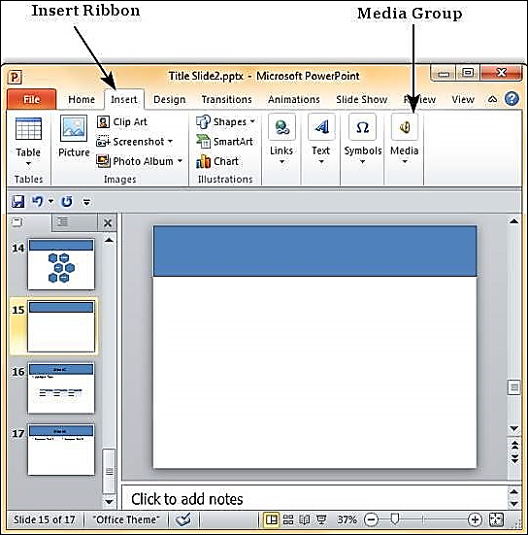

Step 2 − To insert video file select Video as media type and Video from File to insert a video from your computer or hard drive.
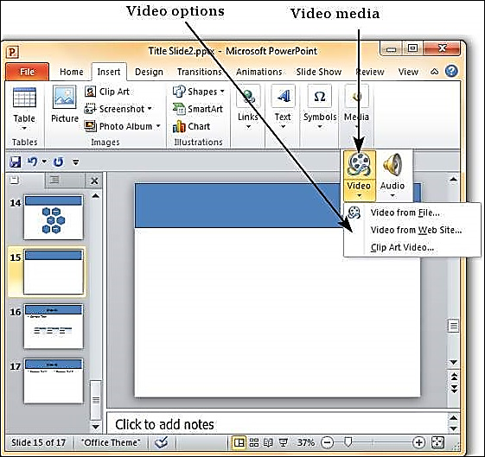

Step 3 − In the Insert Video dialog, browse for a video file and click Insert.
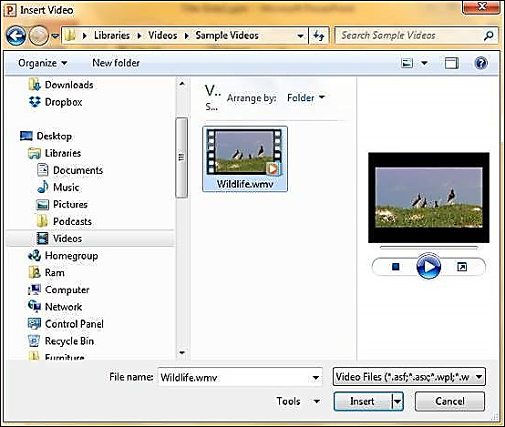
Step 4 − You will now see that a Video file is added to the slide.
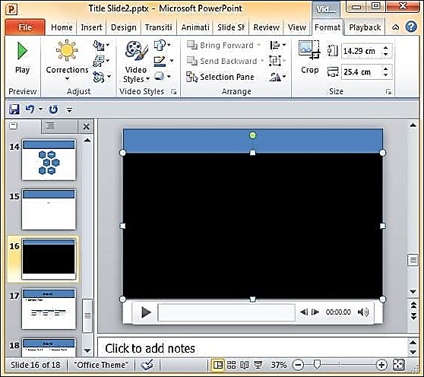
Step 5 − To insert audio file select Audio as media type and Audio from File to insert an Audio from your computer or hard drive.
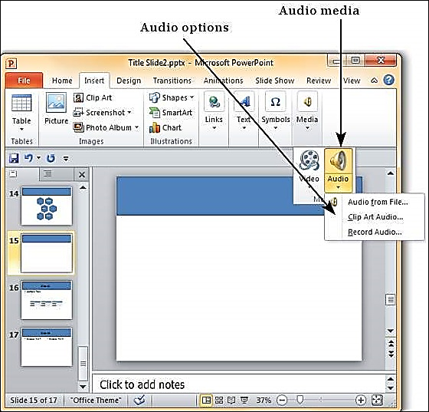

Step 6 − In the Insert Audio dialog, browse for an audio file and click Insert.
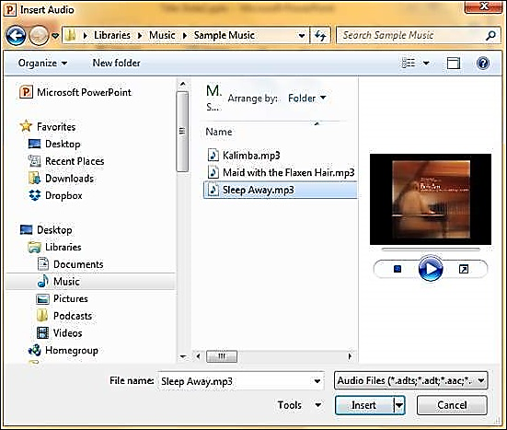

Step 7 − You will now see that an Audio file is added to the slide.
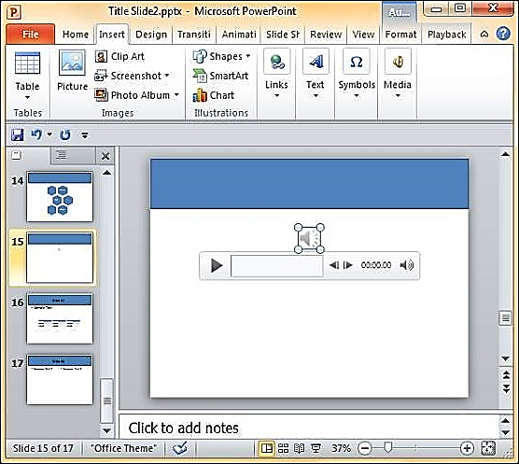

Add text

Select a text placeholder, and begin typing.
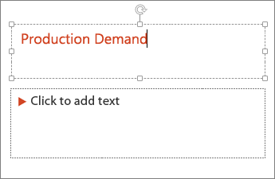

Format your text

- Select the text.
- Under Drawing Tools, choose Format.
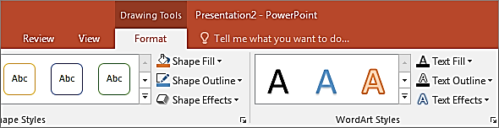
- You can change the format by clicking

Add pictures

On the Insert tab, do one of the following:
- To insert a picture that is saved on your local drive or an internal server, choose Pictures, browse for the picture, and then choose Insert.
- To insert a picture from the web, choose Online Pictures, and use the search box to find a picture.
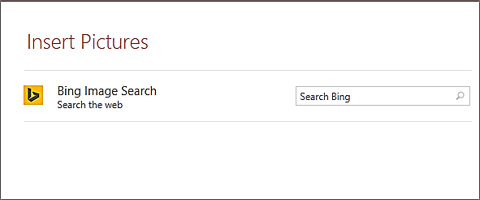
Choose a picture, and then click Insert.

Add shapes

- On the Insert tab, select Shapes, and then select a shape from the menu that appears.
- In the slide area, click and drag to draw the shape.
- Select the Format or Shape Format tab on the ribbon. Open the Shape Styles gallery to quickly add a color and style (including shading) to the selected shape.
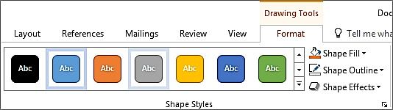

Add speaker notes

Slides are best when you don’t cram in too much information. You can put helpful facts and notes in the speaker notes, and refer to them as you present.
- To open the notes pane, at the bottom of the window, click Notes .
- Click inside the Notes pane below the slide, and begin typing your notes.
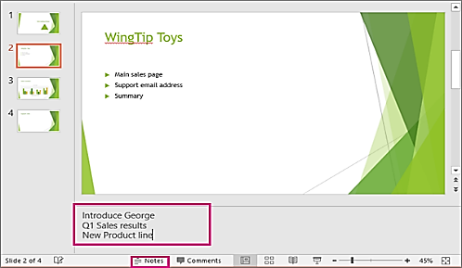

Using Notes in Your Presentations

When you present your slideshow to an audience, only you can see your notes. This makes it a great tool to hold your descriptions, explanations, or instructions as you present your slideshow.
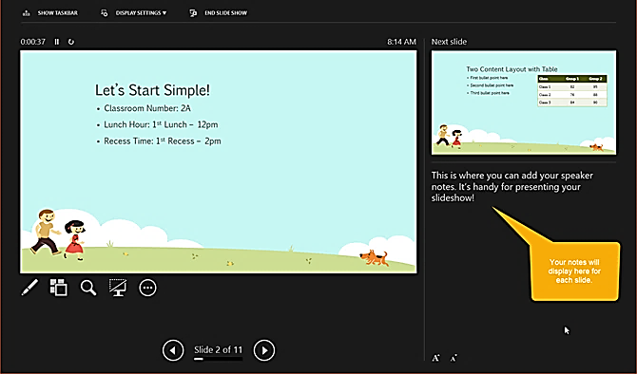

Add Animation

If you are considering adding animations to your slides, it’s super easy to do. Animations can be effective for slideshows you create for education like classroom presentations or college lectures. These are the basic features available on the Animations tab.
- Animation: Choose from a variety of options by clicking the arrow in the Animation
- Effect Options: Different animations have extra options for you to pick from.
- Advanced Animation: Here you can add an animation, open the Animation Pane for more working room, set up a trigger, or use the Animation Painter.
- Timing: Decide how you want your animations to appear on the slide. You can pick a duration time, delay time, and reorder your animations.
- Preview: Once you add an animation you can see a quick view of how it will look without exiting the editing mode or opening the presentation view.
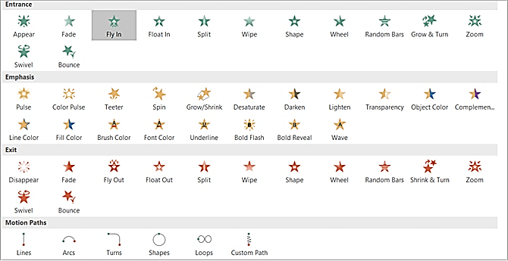

Apply Transition Effects

Inserting transitions between your slides can be another effective way to keep your audience’s attention, similar to animations. You can apply a unique visual, with or without sound, as you move through the slides of your presentation.
Transition Options
These are the basic features available on the Transitions tab.
- Transition to This Slide: Pick from the transition options by clicking the arrow in the box.
- Effect Options: Different transitions have extra options that you can apply. For example, the Wipe, Wind, and Orbit transitions let you pick the direction.
- Timing: Here you can add a sound to go with your transition, pick a duration time, and apply these items to all slides.
- Preview: Once you add a transition you can see a quick view of how it will look without exiting the editing mode or opening the presentation view.
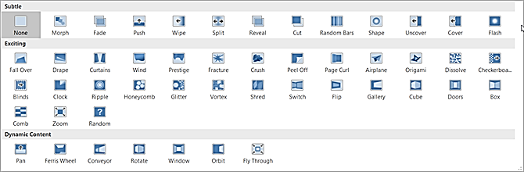

Use Different Presentation Views

Not everyone works the same way when it comes being creative. Luckily PowerPoint offers different built-in views to accommodate this. Just select the View tab and take a look at the ways in which you can work with your slideshow.
The Presentation Views section holds five unique ways to create or edit your slideshow. One of those is the Notes Page which you read about above. And, here are the other four with brief explanations.
- Normal: As you can probably guess, this is the basic, normal view. You should see your slides on the left as numbered thumbnails and the current slide in the largest section to the right. This view works well if you prefer to jump between slides visually.
- Outline View: For those who prefer to write or create using outlines, this view is ideal. You can write directly within the outline pane on the left or paste an existing outline from

Microsoft Word directly in. Here again, the current slide is in the largest section to the right.
- Slide Sorter: This is a terrific way to see all of your slides at a glance. Taking up the entire center window, you can see each slide and can reorder them easily with a drag-and-drop action.
- Reading View: If you want to see your entire presentation without switching to full-screen mode, then just click this button. You can view your slideshow with animations and transitions easily.
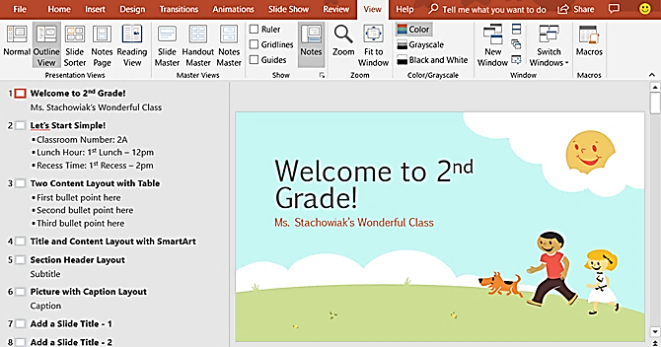
Along with the Slide Sorter view, the Normal and Outline Views allow you to quickly reorder your slides. Just select one and then drag it to its new location.

Save your presentation

- On the File tab, choose Save.
- Pick or browse to a folder.
- In the File name box, type a name for your presentation, and then choose Save.
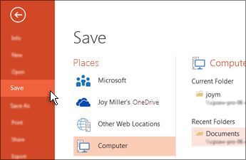
Tip: Save your work as you go. Press Ctrl+S often.

Give your presentation

On the Slide Show tab, do one of the following:
- To start the presentation at the first slide, in the Start Slide Show group, click From Beginning.
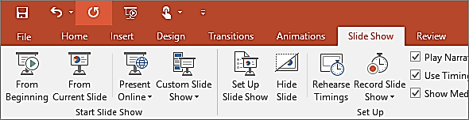
- If you’re not at the first slide and want to start from where you are, click From Current Slide.
- If you need to present to people who are not where you are, click Present Online to set up a presentation on the web, and then choose one of the following options:
    - Broadcast your PowerPoint presentation online to a remote audience
    - Start an online presentation in PowerPoint using Skype for Business

Get out of Slide Show view
To get out of Slide Show view at any time, on the keyboard, press Esc.

Record a slide show with narration and slide timings

Your students, would like to listen or watch back your PowerPoint Supported classroom presentations/lessons especially those students with hearing and visual disability. Hence, you may have to record your lesson with your voice added to it. This section helps you to do so.

Narrations and timings can enhance a web-based or self-running slide show. If you have a sound card, microphone, and speakers, and (optionally) a webcam, you can record your PowerPoint presentation and capture narrations, slide timings, and ink gestures.
After you have made the recording, it's like any other presentation that can be played for you or your audience in Slide Show—or you can save the presentation as a video file.

Record a slide show
- With your presentation open, on the Slide Show tab, click Record Slide Show.
  - Clicking the upper half of the button starts you on the current slide.
  - Clicking the lower half of the button gives you the option to start from the beginning or from the current slide.

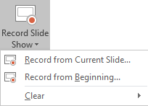
(The Clear command deletes narrations or timings, so be careful when you use it. Clear is grayed out unless you have previously recorded some slides.)
- In the Record Slide Show box, check or clear the boxes for your recording, and click Start Recording.

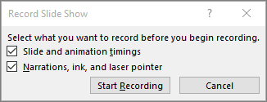
More about these options:
- Slide and animation timings: PowerPoint automatically records the time you spend on each slide, including any animation steps that occur, and the use of any triggers on each slide.
- Narrations, ink, and laser pointer: Record your voice as you run through your presentation. If you use the pen, highlighter, eraser, or laser pointer, PowerPoint records those for playback as well.
Important: Pen, highlighter, and eraser recording are available only if you have the February 16, 2015 update for PowerPoint 2013 or a later version of PowerPoint installed. In earlier versions of PowerPoint, pen and highlighter strokes are saved as ink annotation shapes.
- At the top left corner of the window is the Recording toolbar, which you can use to:
- Go to the next slide:
- Pause the recording:
- Re-record the current slide:
If you re-record your narration (including audio, ink, and laser pointer), PowerPoint erases your previously recorded narration (including audio, ink, and laser pointer) when you start recording again on the same slide.

You can also re-record by going to Slide Show > Record Slide Show.
- To use ink, eraser, or the laser pointer in your recording, right-click the slide, click Pointer options, and pick your tool:
- Laser Pointer
- Pen
- Highlighter
- Eraser (This option is grayed out unless you have previously added ink to some slides.)
To change the color of the ink, click Ink Color.

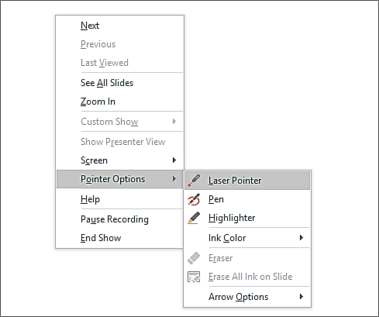
- To end your recording, right-click the final slide, and click End Show.
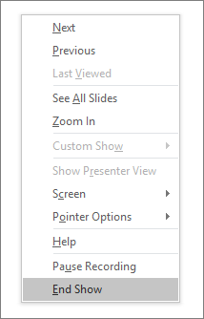
Tip: When you finish recording your narration, a sound icon appears in the lower-right corner of each slide that has narration.

The recorded slide show timings are automatically saved. Timings are shown in Slide Sorter view just beneath each slide.
In this process, what you record is embedded in each slide, and the recording can be played back in Slide Show. A video file is not created by this recording process. However, if you want a video

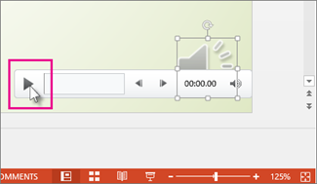

Set the slide timings manually
PowerPoint automatically records your slide timings when you add narrations, or you can manually set the slide timings to accompany your narrations.
- In Normal view, click the slide that you want to set the timing for.
- On the Transitions tab, in the Timing group, under Advance Slide, select the After check box, and then enter the number of seconds indicating how long the slide should appear on the screen. Repeat the process for each slide that you want to set the timing for.
Tip: If you want the next slide to appear either when you click the mouse or automatically after the number of seconds that you enter—whichever comes first—select both the On Mouse Click and the After check boxes.

Delete timings or narration
The Clear command is for deleting timings or narration from your recording that you don't want or that you want to replace. There are four different Clear commands that allow you to:
- Delete the timings on the currently selected slide
- Delete the timings on all slides at once

- Delete the narration on the currently selected slide
- Delete the narration on all slides at once
- If you do not want to delete all the timings or narration in your presentation, open a specific slide that has a timing or narration that you do want to delete.
- On the Slide Show tab of the PowerPoint ribbon, on the Record Slide Show button, click the down arrow, point to Clear, and then choose the appropriate Clear command for your situation.

Turn off timings or turn off narrations, ink, and laser pointer
After you've recorded your PowerPoint presentation, any timings, gestures, and audio you performed are saved on the individual slides. But you can turn them all off if you want to view the slide show without them:
- To turn off recorded slide timings: On the Slide Show tab, clear the Use Timings box.
- To turn off recorded narrations, ink, and the laser pointer: On the Slide Show tab, clear the Play Narrations box.

Recording tips

- Recordings are added to the presentation on a per-slide basis, so if you want to change a recording, you only have to re-record the affected slide or slides. Also, you can rearrange the order of slides after recording without having to re-record anything. This also means it's easy to pause for a break while recording a presentation.
- PowerPoint doesn't record audio or video during transitions between slides, so don't speak while advancing the slide. Also, include a brief buffer of silence at the beginning and the end of each slide to make the transitions smooth and ensure that you don't cut off audible narration while transitioning from one slide to the next.
- You can't record narration in PowerPoint for the web. Use a desktop version of PowerPoint to record your narration.
- You can adjust and edit the size of video and ink in edit view.
- If it's possible that your audience may use PowerPoint for the web to experience the recording, use the transitions that are supported by PowerPoint for the web (Cut, Fade, Push, Wipe, Split, Random Bars, Shape, Morph).
- Presentation recording works best with touch-screen PCs that have a web camera.
- Use video preview to make sure everything is set up correctly before recording.
- For slides that you want to record gestures (such as ink) on, make multiple copies of the slide so that you can easily record multiple takes. Then delete the extraneous slides when you're done.
- Record a few seconds of silence by turning off audio and video to advance after a set time.

- For higher quality, use an external web cam and/or microphone.
Built-in cameras and microphones are suitable for most tasks. But if you want more professional-looking video, consider using an external web cam, if you're able. If you're using PowerPoint on a tablet or laptop and you're inking with a stylus, an external camera and microphone allows you to minimize stylus noise.
- As soon as you finish your first slide recording, play it back.
Before you get too far down the road of recording your presentation, make sure your audio and video sound and look the way you expect.

Tips for creating an effective presentation

Consider the following tips to maintain a clear message and to keep your audience attentive and interested.
- Minimize the number of slides - keep the number of slides in your presentation to a minimum.
- Choose an audience-friendly font size - font size smaller than 30 might be too difficult for the audience to see from distance.
- Keep your slide text simple - use bullets or short sentences, and try to keep each item to one line. Some projectors crop slides at the edges, so that long sentences might be cropped.
- Use visuals to help express your message – pictures, charts, graphs, and SmartArt graphics provide visual cues for your audience to remember. As with text, however, avoid including too many visual aids on your slide.
- Make labels for charts and graphs understandable – use only enough text to make label elements in a chart or graph comprehensible.
- Check the spelling and grammar – to earn and maintain the respect of your audience, always check the spelling and grammar in your presentation

