Unpacking your thoughts

- What do you expect from this training? Individually write three things you expect from this training.

- Now in pairs, make six expectations. If your former expectations are similar, add new ones now.

Unit I – Basic Computer Skills for ELT Professionals

Objectives

At the end of this unit, you will be able to:
- Identify parts of a computer
- Open a computer
- Use a computer
- Shut down a computer properly

Getting Ready

- What do you know about computers? Write all the words you know in relation to computers?
- In pairs, explain the functions of the parts in the following picture. You should also explain how these tools can be used in ELT.
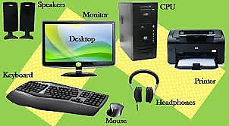

Introduction

In order to properly use a computer or computing device it is necessary to have a basic understanding of what a basic computer is and how it operates. All computers have two things in common, hardware and software.
- Hardware is what the computer is physically made up of; which includes the monitor, keyboard and mouse, and all of its internal components which allows it to store, receive, and process information and data.
  - The central processing unit (CPU), or processor, contains logic circuitry and performs the instructions of a computer’s programs. It is the “brain” of the computer.
  - Read-only memory (ROM) is the memory that comes with your computer that is pre-written to hold the instructions for booting-up the computer. Information can be read from ROM, but not written back to it. ROM will retain data when the computer is powered off. It is known as non-volatile memory.
  - Random access memory (RAM) is the memory available for the operating system, programs and processes to use when the computer is running. RAM can be read from, and written to, for processing information and instructions. Data in RAM is not permanently written and therefore known as volatile memory. When you power off your computer the data stored in RAM is deleted.

- Software is made up of informational data and code that acts as a set of instructions informing the hardware what actions it is to perform or initiate. (ie. Software applications: The computer’s operating system, Microsoft Word (word processing), Excel (spreadsheets and data calculation), Web browsers: Internet Explorer, Mozilla Firefox, Google Chrome, and Apple Safari, Search engines: Google, Bing, Yahoo)
There are several different kinds of computers. The most common computers are desktop computers, laptop computers, tablet or touchscreen computers, and servers which allow computers to network and connect with each other via the local area networks (LAN) or the Internet. Other examples of computers may also include smart phones, gaming counsels, kiosks and computers that may also be found in home appliances such as TVs, refrigerators, and vehicles which make use of software applications or apps to connect and communicate with Internet service.
A computer is more than just another household appliance. The vast amount of information and possibilities can be overwhelming.

keyboard and mouse

You interact with a computer mainly by using the keyboard and mouse, or a trackpad on laptops. Most people find it comfortable to place the keyboard on the desk directly in front of them and the mouse to one side of the keyboard.
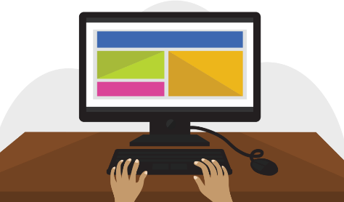

The mouse controls the pointer on the screen. Whenever you move the mouse across the desk, the pointer will move in a similar manner. A mouse usually has three buttons (left, right and middle button). You will often interact with the computer by moving the mouse pointer over something on the computer screen, then clicking one of the buttons.
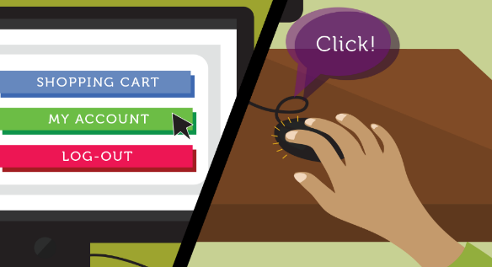
On laptops, you can use the trackpad, located below the keyboard, instead of a mouse. Simply drag your finger across the trackpad to move the pointer on the screen. Some trackpads do not have buttons, so you'll either press or tap the trackpad to click.

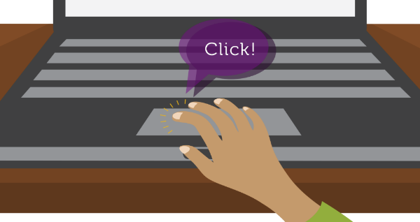
The keyboard allows you to type letters, numbers, and words into the computer. Whenever you see a flashing vertical line—called the cursor—you can start typing.
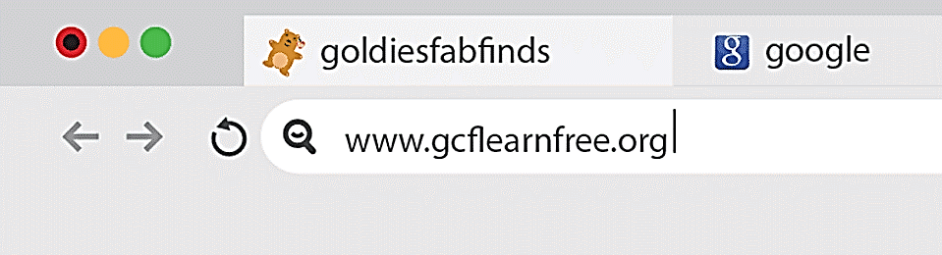

Turning on a computer

The very first step is to turn on the computer. Make sure all the cables are plugged in correctly, and locate the power button. It's in a different place on every computer, but it will have the universal power button symbol (shown below).
Once turned on, your computer takes time before it's ready to use. You may see a few different displays flash on the screen. This process is called booting up, and it can take anywhere from 15 seconds to several minutes. Once the computer has booted up, it may be ready to use, or it may require you to log in. This means identifying yourself by typing your user name or selecting your profile, then typing your password. If you've never logged in to your computer before, you may need to create an account.
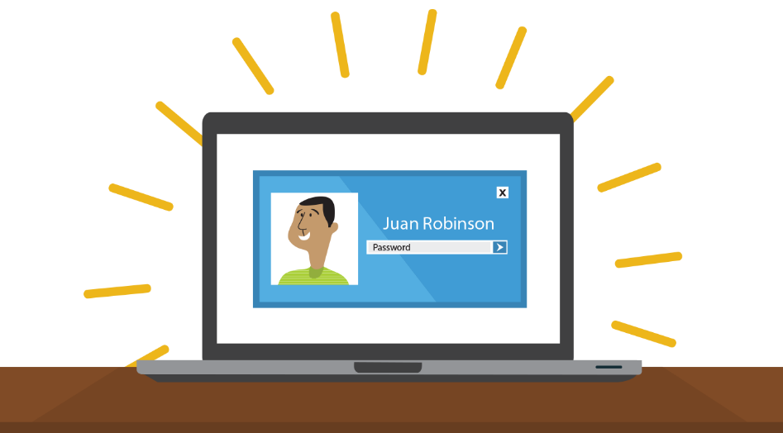

Using a computer

The main screen you'll start from is the desktop. From here, you can access the programs and features you need to use your computer. Icons are used to represent different files, applications, and commands on your computer. An icon is a small image that's intended to give you an idea at a glance of what it represents, like a logo. Double-clicking an icon on the desktop will open that application or file.

A button is a command that performs a specific function within an application. The most commonly used commands in a program will be represented by buttons.
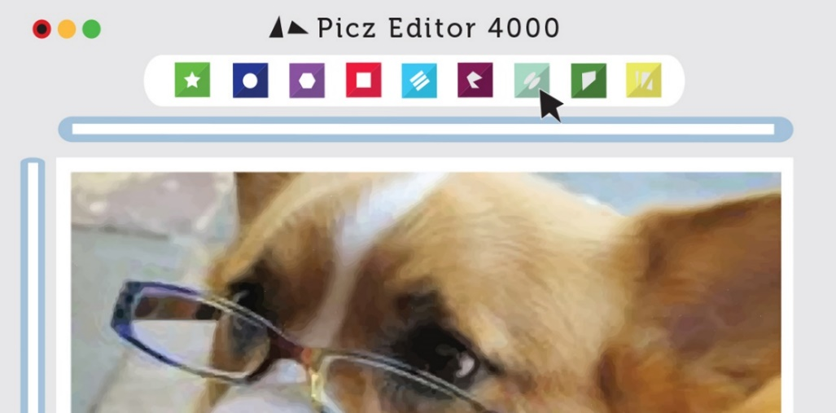
Menus are organized collections of commands and shortcuts. Click a menu to open it and display the commands and shortcuts within. Then click an item in the menu to execute it.
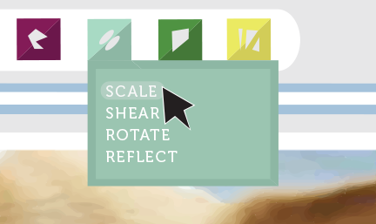
When you open an application or folder, it is displayed in its own window. A window is a contained area—like a picture within a picture—with its own menus and buttons specific to that program.

You can rearrange multiple windows on the desktop and switch between them.
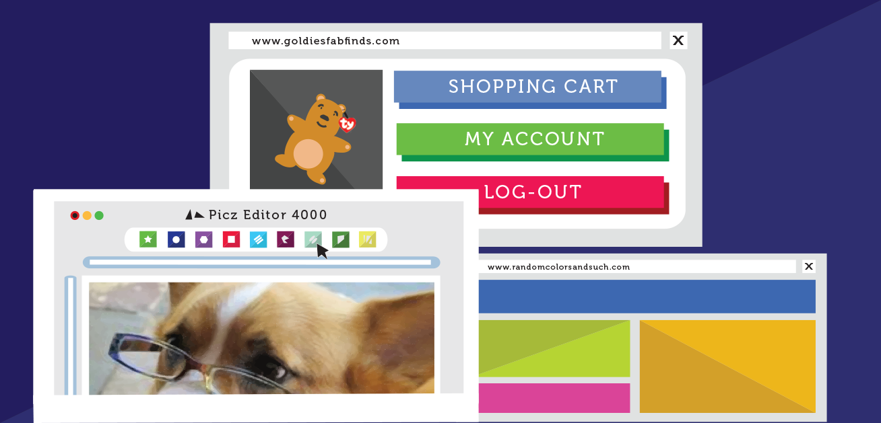

Opening file and application systems

The file system icon will be in the bottom-left part of the screen. On a PC, the File Explorer icon looks like a folder, as in the image below.
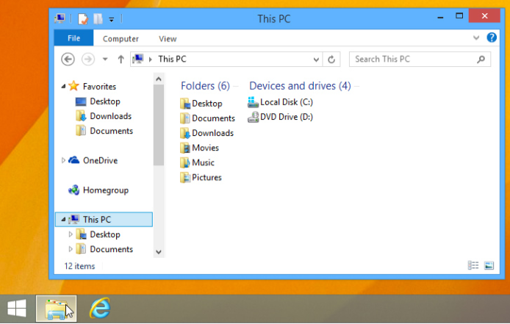
When you double-click a file, your computer will automatically use the correct application to open it. In our example, we're opening a Microsoft Word document (Chicago Trip Details), which will open in Microsoft Word.

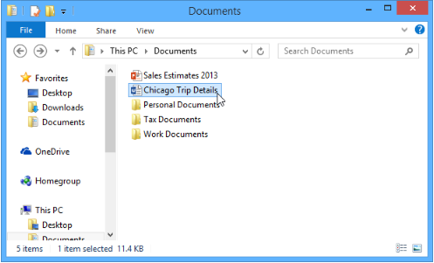
However, there may be times you may want to open an application directly, instead of just opening a file.
- To open an application, click the Start button, then select the desired application. If you don't see the one you want, you can click All Programs to see a full list, or simply type the name of the application on your keyboard to search for it. In the example below, we're opening Internet Explorer.
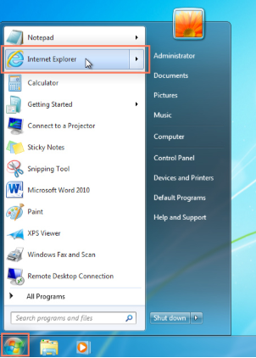

Basic navigation

If you see the file you want, you can double-click it with your mouse. Otherwise, you can use the Navigation pane on the left side of the window to select a different location.

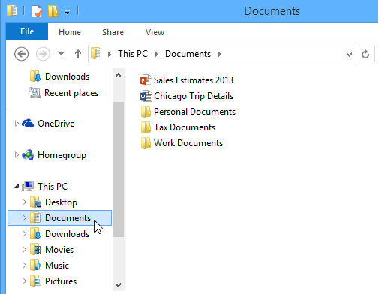

Deleting files

Windows use Recycle Bin—to prevent you from accidentally deleting files. When you delete a file, it is moved to the Trash can. If you change your mind, you can move the file back to its original location.
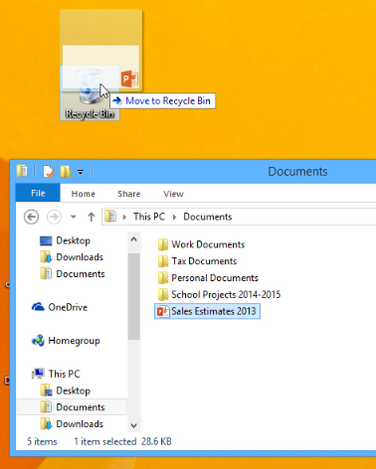
If you want to permanently delete the file, you will need to empty the Recycle Bin. To do this, right-click the icon and select Empty Recycle Bin.
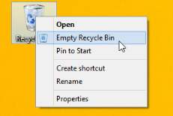

Adjusting computer's settings

When you start using a new computer, you may want to begin by adjusting the computer's settings. Adjusting your settings can range from simple tasks such as changing your desktop background to more advanced tasks like adjusting your security or keyboard settings.
- In Windows 10, click the Start button, then select Settings.
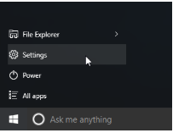
- In Windows 8.1 and earlier, click the Start button, then locate and select the Control Panel.
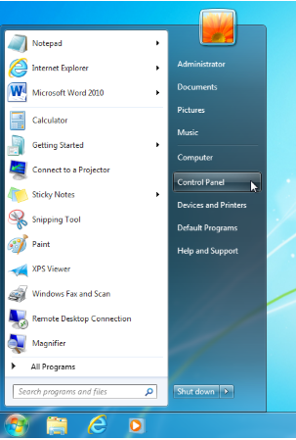

Shutting down computer

When you have done everything that you want using your computer, it's important to shut it down properly.
- To shut down Windows, click the Start button, then select Shut down (in some versions, this may say Turn Off Computer or look like the power symbol).

